In [14]:

*# Get the high cases*

high_cases_value **=**[]

**for** country **in** countries:

high_cases_value.append(cleaned_data[cleaned_data['Country'] **==** country]['New_cases'].values.max()) high_cases_value

1

2

3

4

5

Out[14]: [35253, 3141, 413, 2518, 2609, 2154, 956, 1034]

In [15]:

|  |  |
| --- | --- |
| 1 | *# polot the high cases in all countries* |
| 2 | plt.figure(figsize**=**(20,5)) |
| 3 | plt.title("High cases in all countries") |
| 4 | plt.xlabel("Cases") |
| 5 | plt.ylabel("Number of cases") |
| 6 | plt.bar(countries,high_cases_value,label**=**"countries",color **=** 'red') |
| 7 | plt.legend(loc**=**"upper left") |
| 8 | plt.show() |

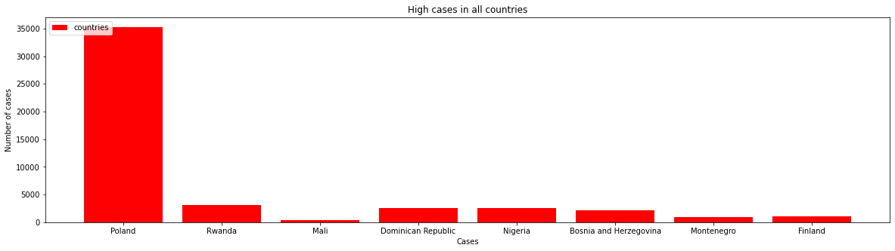

In [16]:

*# Get the high Cumulative_deaths*

high_Cumulative_deaths **=**[] **for** country **in** countries:

high_Cumulative_deaths.append(cleaned_data[cleaned_data['Country'] **==** country]['Cumulative_deaths'].values.max() high_Cumulative_deaths

1

2

3

4

5

Out[16]: [75392, 1105, 539, 4012, 2488, 9906, 1757, 1031]

In [17]:

|  |  |
| --- | --- |
| 1 | *# polot the high Cumulative_deaths in all countries* |
| 2 | plt.figure(figsize**=**(20,5)) |
| 3 | plt.title("High Cumulative deaths in all countries") |
| 4 | plt.xlabel("Cumulative deaths") |
| 5 | plt.ylabel("Number of Cumulative deaths") |
| 6 | plt.bar(countries,high_Cumulative_deaths,label**=**"countries",color **=** 'yellow') |
| 7 | plt.legend(loc**=**"upper left") |
| 8 | plt.show() |

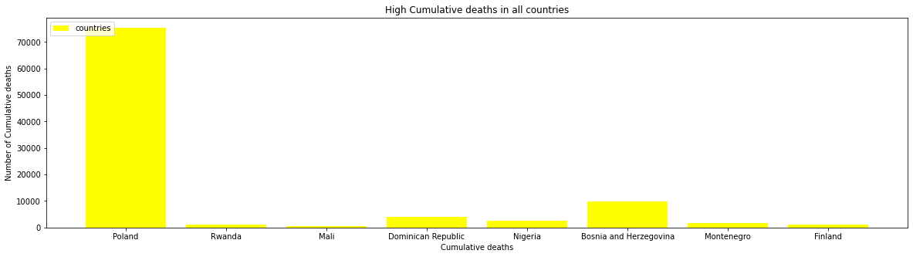

In [18]:

|  |  |
| --- | --- |
| 1 | *# Get the cumulative death in country such as Mali* |
| 2 | cumulative_Mali **=** cleaned_data[cleaned_data['Country'] **==** 'Mali']['Cumulative_deaths'].values |

In [19]:

|  |  |
| --- | --- |
| 1 | *# Get the all dates for Mali* |
| 2 | all_date_mali **=** cleaned_data[cleaned_data['Country'] **==** 'Mali']['Date_reported'].values |

In [20]:

|  |  |
| --- | --- |
| 1 | *# polot the cumulative death in Mali over all dates* |
| 2 | plt.figure(figsize**=**(20,5)) |
| 3 | plt.title("The cumulative death in Mali over all dates") |
| 4 | plt.xlabel("The Date") |
| 5 | plt.ylabel("The cumulative death") |
| 6 | plt.plot(all_date_mali,cumulative_Mali,label**=**"Mali",color **=** 'red') |
| 7 | plt.legend(loc**=**"upper left") |
| 8 | plt.show() |

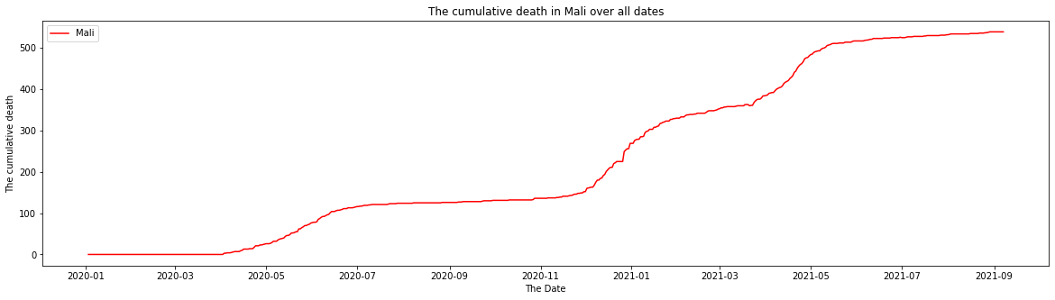

In [21]:

|  |  |
| --- | --- |
| 1 | *# Get Mali new deathes over the all dates* |
| 2 | new_deaths_Mali **=** cleaned_data[cleaned_data['Country'] **==** 'Mali']['New_deaths'].values |
| 3 | all_date_mali **=** cleaned_data[cleaned_data['Country'] **==** 'Mali']['Date_reported'].values |

In [22]:

|  |  |
| --- | --- |
| 1 | *# plot the new deaths in Mali and Poland over the all dates* |
| 2 | plt.figure(figsize**=**(20,5)) |
| 3 | plt.title("The New deaths in Mali over all dates") |
| 4 | plt.xlabel("The Date") |
| 5 | plt.ylabel("The New death") |
| 6 | plt.plot(all_date_mali,new_deaths_Mali,label**=**"Mali",color **=** 'red') |
| 7 | plt.legend(loc**=**"upper left") |
| 8 | plt.show() |
| 9 |  |

